# Resultado de imagen para cortando vidrioI was working on putting glasses in a house.



But at the time of cutting a long piece the glass broke leaving pieces in the floor



# And at the time momento of liffing the pieces I cut my

# hand

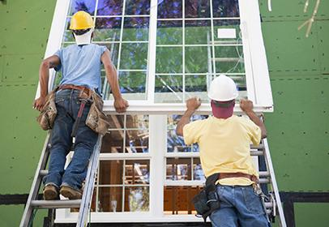Thing happened it was time to place them because it coul not hold the glass well

It was on a second floor



And there was possibility of throwing it

But I could be placed ofter several attempts